UNIT II
- Draw the block diagram of a DC power supply and explain each block
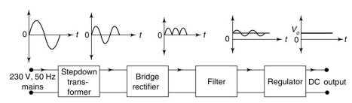
The basic building blocks of a regulated DC power supply are as follows:
- A step down transformer
- A rectifier
- A DC filter
- A regulator

Step Down Transformer
A step down transformer will step down the voltage from the ac mains to the required voltage level. The turn’s ratio of the transformer is so adjusted such as to obtain the required voltage value. The output of the transformer is given as an input to the rectifier circuit.

Rectification
. Rectification is the process of converting an alternating voltage or current into corresponding direct (DC) quantity. The input to a rectifier is ac whereas its output is unidirectional pulsating DC. Usually a full wave rectifier or a bridge rectifier is used to rectify both the half cycles of the ac supply (full wave rectification).

DC Filtration
The rectified voltage from the rectifier is a pulsating DC voltage having very high ripple content. But this is not we want, we want a pure ripple free DC. Hence a filter is used. Different types of filters are used such as capacitor filter, LC filter, Choke input filter, π type filter.
Regulation
This is the last block in a regulated DC power supply. The output voltage or current will change or fluctuate when there is change in the input from ac mains or due to change in load current at the output of the regulated power supply or due to other factors like temperature changes. This problem can be eliminated by using a regulator. A regulator will maintain the output constant even when changes at the input or any other changes occur.
- Define rectifier. Classify the rectifiers
Rectifier is defined as an electronic device used for converting a.c. voltage into unidirectional voltage.
Rectifiers are classified depending upon the period of conduction as
- Half-wave (b) Full-wave rectifier.
Full Wave rectifier further classified as (i) center tapped FWR (ii) Bridge Rectifier
- Explain the operation of half wave rectifier with circuit diagram. Draw the input and output waveforms
It converts an a.c. voltage into a pulsating d.c. voltage using only one half of the applied a.c. voltage. The rectifying diode conducts during one half of the a.c. cycle only.
Figure shows the basic circuit and waveforms of a half-wave rectifier
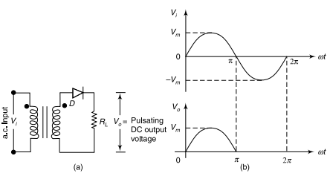
Fig: (a) Half wave Rectifier (b) Input and Output wave forms
Let V_{i} be the voltage to the primary of the transformer and given by the equation
Vi = V_{m} sin wt; V_{m} >> V_{ʸ} where V_{ʸ} is the cut-in voltage of the diode.
During the positive half cycle of the input signal, the anode of the diode becomes more positive with respect to the cathode and hence, diode D conducts. For an ideal diode, the forward voltage drop is zero. So the whole input voltage will appear across the load resistance, R_{L}.
During negative half cycle of the input signal, the anode of the diode becomes negative with respect to the cathode and hence, diode D does not conduct. For an ideal diode, the impedance offered by the diode is infinity. So the whole input voltage appears across diode D. Hence, the voltage drop across R_{L} is zero.
The input and output waveforms are shown in fig (b)
- Explain the operation of Full wave rectifier with circuit diagram. Draw the input and output waveforms.
It converts an a.c. voltage into a pulsating d.c. voltage using both half cycles of the applied a.c. voltage. It uses two diodes of which one diode conducts during one half-cycle while the other diode conducts during the other half-cycle of the applied a.c. voltage.
Figure shows the basic circuit and waveforms of full-wave rectifier with a center tap transformer.
During positive half of the input signal, anode of diode D₁ becomes positive and at the same time the anode of diode D₂ becomes negative. Hence, D₁ conducts and D₂ does not conduct. The load current flows through D1 and the voltage drop across RL will be equal to the input voltage.
During the negative half-cycle of the input, the anode of D₁ becomes negative and the anode of D₂ becomes positive. Hence, D₁ does not conduct and D₂ conducts. The load current flows through D₂ and the voltage drop across R_{L} will be equal to the input voltage
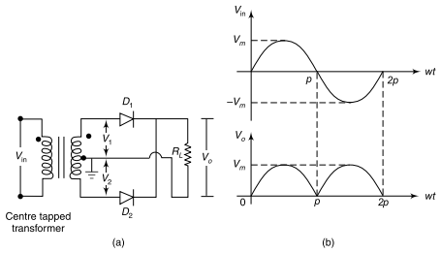
Fig: (a) Full wave Rectifier (b) Input and Output wave forms
The input and output waveforms are shown in fig (b)
- Explain the operation of Bridge rectifier with circuit diagram. Draw the input and output waveforms
As shown in Fig, the bridge rectifier has four diodes connected to form a bridge. The a.c. input voltage is applied to the diagonally opposite ends of the bridge. The load resistance is connected between the other two ends of the bridge
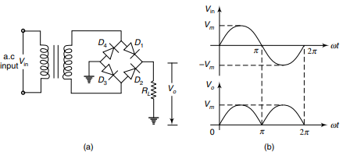
Fig: (a) Bridge Rectifier (b) Input and Output wave forms
For the positive half-cycle of the input a.c. voltage, diodes D₁ and D₃ conduct, whereas diodes D₂ and D₄ do not conduct. The conducting diodes will be in series through the load resistance R_{L}. So the load current flows through R_{L}.
During the negative half-cycle of the input a.c. voltage, diodes D₂ and D₄ conduct, whereas diodes D₁ and D₃ do not conduct. The conducting diode D₂ and D₄ will be in series through the load R_{L} and the current flows through R_{L} in the same direction as in the previous half-cycle. Thus a bidirectional wave is converted into an unidirectional one.
The input and output waveforms are shown in fig (b)
- What is the advantage of Bridge rectifier over a center tapped full wave rectifier?
- No center tapped transformer
- PIV is only Vm
- Transformer utilization factor is 0.812

- What is the purpose of using filters in rectifier circuits?
Filters are used to minimize the undesirable a.c., i.e. ripple leaving only the d.c. component to appear at the output.
- Draw the output wave form of rectifier with capacitor filter?
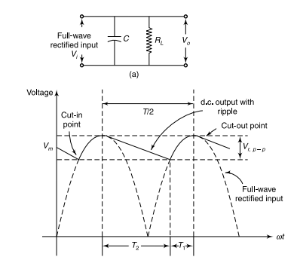
(b)
Fig (a) capacitor filter (b) Output wave form
- What is Zener effect. Explain how the Zener diode can be used as a voltage regulator with necessary circuit diagram.
Zener effect: The Zener effect is a type of electrical breakdown that occurs in a reverse-biased PN junction when the electric field enables tunnelling of electrons from the valence to the conduction band of a semiconductor, leading to a large number of free minority carriers which suddenly increase the reverse current.
Zener diode can be used as a voltage regulator
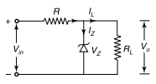
Fig: Zener diode can be used as a regulator
A zener diode, under reverse bias breakdown condition, can be used to regulate the voltage across a load, irrespective of the supply voltage or load current variations.
A simple zener voltage regulator circuit is shown in Fig. The zener diode is selected with Vz equal to the voltage desired across the load. The zener diode has a characteristic that under reverse bias condition, the voltage across it practically remains constant, even if the current through it changes by a large extent.
Under normal conditions, the input current Ii = I_{L} + I_{Z} flows through resistor R. The input voltage Vi can be written as Vi = IiR + Vz = (I_{L} + Iz) R + Vz. When the input voltage Vi increases, as the voltage across zener diode remains constant, the drop across resistor R will increase with a corresponding increase in I_{L} + I_{Z}. As V_{Z} is a constant, the voltage across the load will also remain constant and hence, IL will be a constant. Therefore, an increase in I_{L} + I_{Z} will result in an increase in I_{Z} which will not alter the voltage across the load.
- Draw the block diagram of public address system and explain its working principle.
A “Public Address” system is anything that amplifies sound so more people can hear it.
A simple public address system (or PA system) is shown in the following block
diagram.
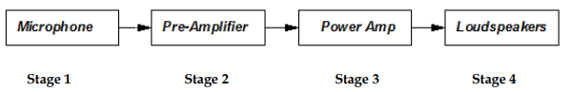
Stage 1: Microphone (Transducer)
The microphone converts sound waves into electrical signals that can be processed by
the rest of the system. It is important that the microphone creates a faithful reproduction
of the sound wave as an electrical signal – no distortion!
Stage 2: Pre-Amplifier
Its purpose is to take the small electrical signals from the microphone and increase the
amplitude of the signal voltage.
Stage 3: Power Amplifier
The power amplifier takes this enlarged voltage signal, and boosts the current so that it
is strong enough to drive the loudspeaker.
Stage 4: Loud Speaker
The loudspeaker is the final part of the system where the electrical signal is transformed
back into a sound wave.
If the system has carried out its function correctly, the emerging sound wave will be an
undistorted but amplified version of the original.
A more sophisticated PA system would allow a number of inputs to be connected
- For example a band would have several microphone inputs and guitar pick-up inputs.
These inputs would need to be faded in or out individually.
- Consider the following block diagram
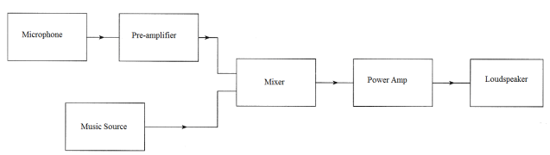
- It can be noticed that there are two additions to the simple PA system. The first is a
music source and the second is a mixer.
- Mixer: Its function is to add together electrical signals from microphones or pick-ups
from electric guitars or backing tracks from a CD player.
- Most music sources produce a much larger signal than a microphone and do not need a pre-amplifier
- In a real system, each microphone would have its own pre-amplifier
- What is the use of a microphone in public address system?
A microphone in a public address system is used to convert sound waves (like a person's voice) into electrical signals, which are then amplified and transmitted through speakers, allowing a large audience to hear the sound clearly; essentially, it acts as the input device that captures the sound to be projected through the system.
- What is the use of a Loud speaker
A loudspeaker, also called a speaker, is a device that converts electrical signals into audible sound waves, allowing you to hear audio output from devices like computers, TVs, and smartphones by essentially making sounds louder through the amplification of electrical signals into physical sound waves.
- Draw the circuit diagram and explain the CE (RC coupled) amplifier. Draw its frequency response.
The two stage amplifier circuit has two transistors, connected in CE configuration and a common power supply VCC is used. The potential divider network R1 and R2 and the resistor Re form the biasing and stabilization network. The emitter by-pass capacitor Ce offers a low reactance path to the signal.
The resistor RL is used as a load impedance. The input capacitor Cin present at the initial stage of the amplifier couples AC signal to the base of the transistor. The capacitor CC is the coupling capacitor that connects two stages and prevents DC interference between the stages and controls the shift of operating point. The figure below shows the circuit diagram of RC coupled amplifier.
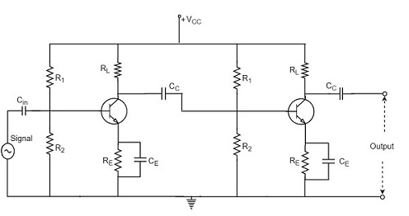
Operation of RC Coupled Amplifier
When an AC input signal is applied to the base of first transistor, it gets amplified and appears at the collector load RL which is then passed through the coupling capacitor CC to the next stage. This becomes the input of the next stage, whose amplified output again appears across its collector load. Thus the signal is amplified in stage by stage action.
Frequency Response of RC Coupled Amplifier
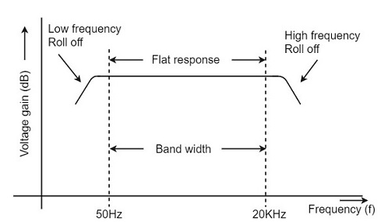
- What are the applications of RC coupled amplifier
Audio amplifiers: Used in home stereos and public address systems
Radio and TV receivers: Used as small signal amplifiers
RF communications: Used in radio transmitters and other RF applications
Optical fiber communications: Used in optical fiber communications
Controllers: Used as controllers
- Explain the concept of voltage divider biasing.
"Voltage divider biasing" is a method used in electronic circuits, particularly with transistors, to establish a stable operating point (Q-point) by using a network of resistors (a voltage divider) to set a precise voltage at the base of the transistor, ensuring consistent performance even when the power supply voltage fluctuates; this provides good stability against temperature variations and other external factors.
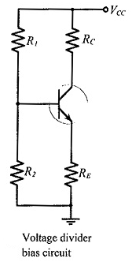
- Explain the block diagram of electronic instrumentation system
It is branch of engineering which deals with various types of instrument to record, monitor, indicate and control various physical parameters such as pressure, temperature, etc.
The block diagram shown above is of basic instrumentation system. It consist of primary sensing element, variable manipulation element, data transmission element and data presentation element.
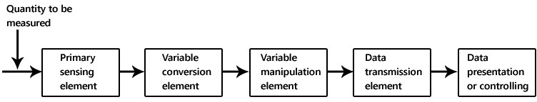
Primary sensing element
The primary sensing element is also known as sensor. Basically transducers are used as a primary sensing element. Here, the physical quantity (such as temperature, pressure etc.) are sensed and then converted into analogues signal.
Variable conversion element
It converts the output of primary sensing element into suitable form without changing information. Basically these are secondary transducers.
Variable manipulation element
The output of transducer may be electrical signal i.e. voltage, current or other electrical parameter. Here, manipulation means change in numerical value of signal. This element is used to convert the signal into suitable range.
Data transmission element
Sometimes it is not possible to give direct read out of the quality at a particular place (Example – Measurement of temperature in the furnace). In such a case, the data should transfer from one place to another place through channel which is known as data transmission element. Typically transmission path are pneumatic pipe, electrical cable and radio links. When radio link is used, the electronic instrumentation system is called as telemetry system.
Data presentation or controlling element
Finally the output is recorded or given to the controller to perform action. It performs different functions like indicating, recording or controlling.

